Layout Plan of 2-Bedroom Unit-Large (for 4 persons)

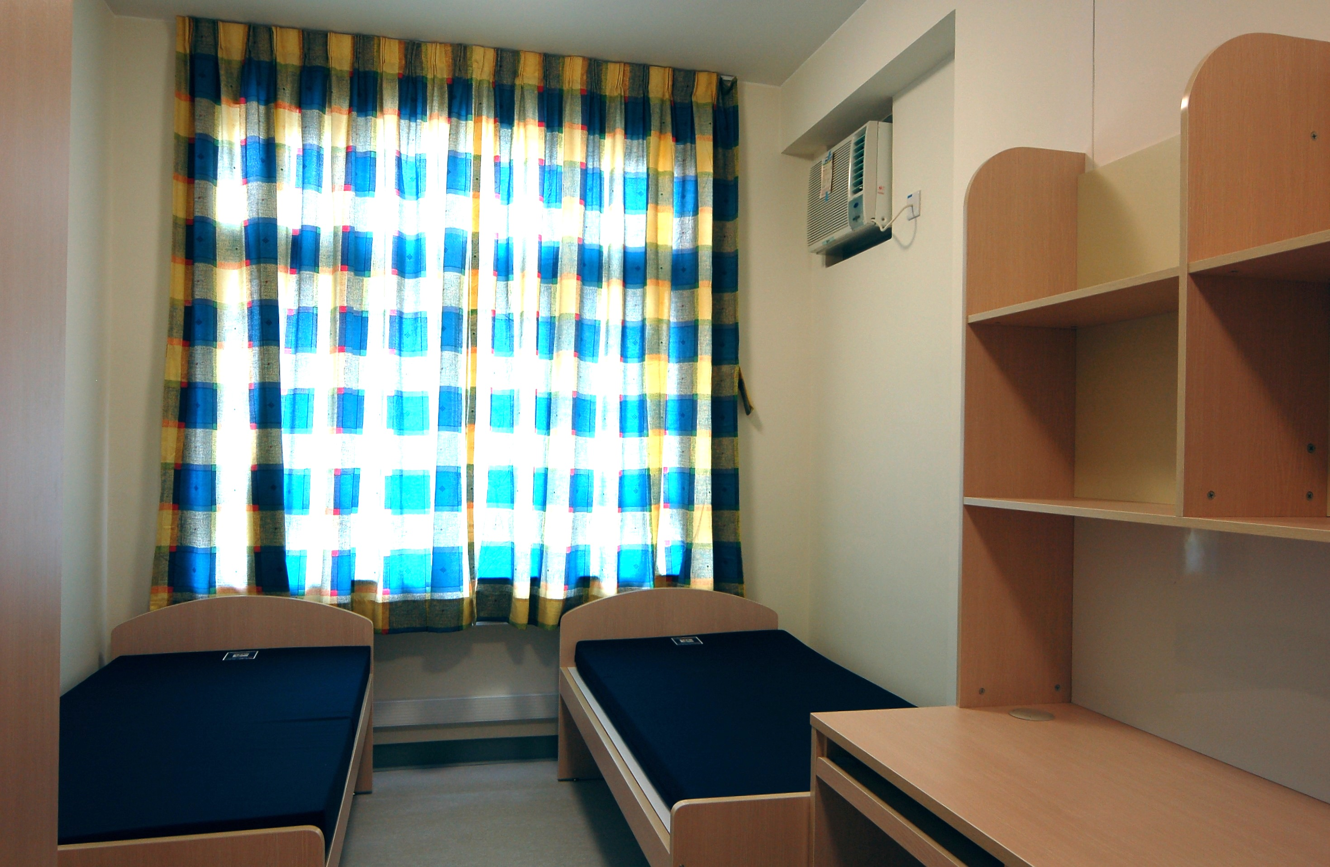
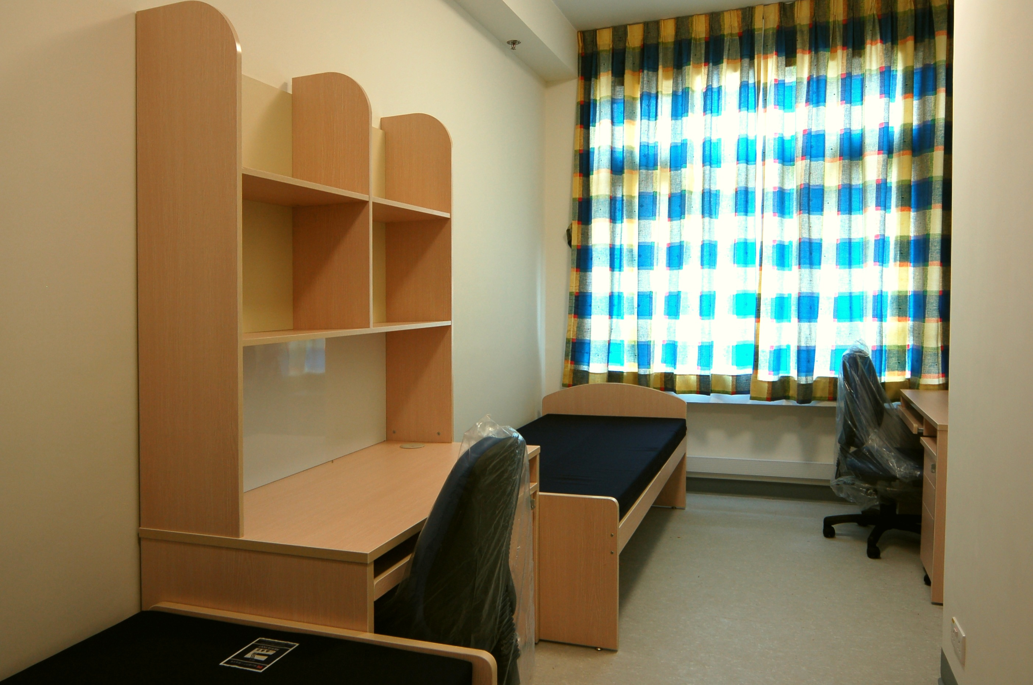

3
5
5
5

2
10
Living Room
Bedroom A
4
10
Toilet & Shower Room
3
3
4
5
4
Bedroom B

2
2
3
4
2
Kitchenette

6

10
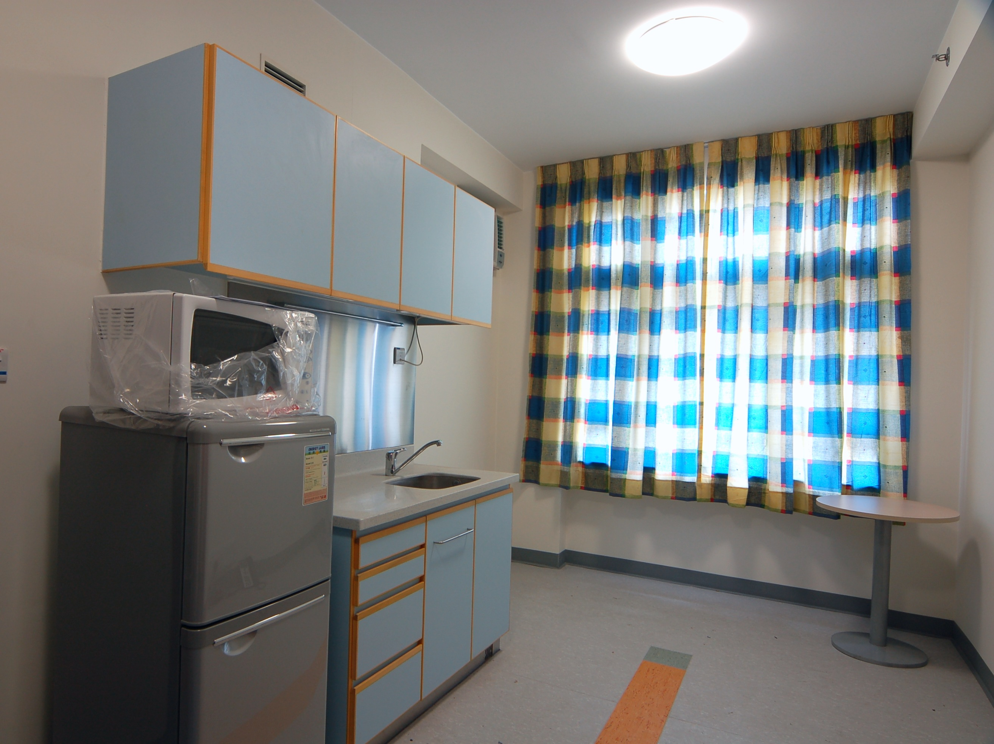

Furniture & Facilities of 2-Bedroom-Regular
No. shown on Layout Plan | Furniture & Facilities | Quantity
2 | Bed | 4
3 | Desk | 4
4 | Chair | 4
5 | Wardrobe | 4
6 | Table | 1
10 | Pedestal | 4

